 | Undersink Water Filter System  Installation Instructions – 3 Way Faucet  037034-002

GENERAL INSTRUCTIONS:
- Do not use with water that is microbiologically unsafe or of unknown quality without adequate disinfection before or after the system
- Systems certified for cyst reduction (see “Performance Data” supplied with filter system) may be used on disinfected waters that may contain filterable cysts.

NOTICES:
- Install this filter on a cold water line only
- Water pressure – Minimum 1.5 bar ; Maximum 8 bar
- Protect unit from direct sunlight and freezing temperatures
- Clean unit with water safe products that will not taint drinking water – do not use bleach or spray cleaners
- This product is intended for indoor use only
- For extended periods of non-use, turn off the water supply and remove the filter cartridge. Place the filter cartridge in a sealed plastic bag and store in a refrigerator
- Before use, flush the filter media for 5 minutes
- Change the filter cartridge if changes in taste, colour or water flow occur
- Only use filter cartridges designed for use with this filtration system

KIT CONTENTS:
TOOLS NEEDED:
- Phillips screwdriver
- PTFE Tape (“plumbers tape”)
- Sharp knife (e.g. Stanley knife)

PRE INSTALLATION CHECKS:
- Ensure that there is sufficient space to install the product without it hampering its operation. When fitting in a corner position make sure there is sufficient clearance for the use of the handles and the movement on the spout.
- Ensure that the outlet will protrude sufficiently into the sink(s) and will clear any obstructions.
- When installing the product the hot inlet should be on the left hand side and the cold on the right hand side and the filter handle facing the front.

INSTALLATION INSTRUCTIONS:
Step 1: Remove existing tap (where applicable)
- Turn off the water supply and turn on the tap to drain the system.
- Remove the old kitchen tap by disconnecting any flexible hoses or copper tails from the domestic
- supply. Unscrew any clamping nuts and screws from the underside of the tap.
- Once the old tap is removed, clean around the sink tap hole and ensure it is clean from dirt and debris.
- Check the size of the sink tap hole – recommended size for the OASIS three way faucet is as follows:
  - 034826-221 (KDF-02): 36mm hole
  - 034826-321 (KDF-03) 34mm hole
Please note, depending on how your old faucet was connected to the mains water supply you may be able to use these connections to install your new faucet, or you may need to plug the old connectios

Step 2: Assemble hoses and threaded studs to new faucet
- Attach the three braided hoses to the three holes in the base of the faucet. The red and blue hoses are for hot & cold water connections respectively. Tighten the hoses securely by hand – this will ensure that the O-ring seals will prevent any water leaks
- Then attach the two threaded studs to the two holes in the base of the faucet

Model KDF-02 Faucet | Model KDF-03 Faucet
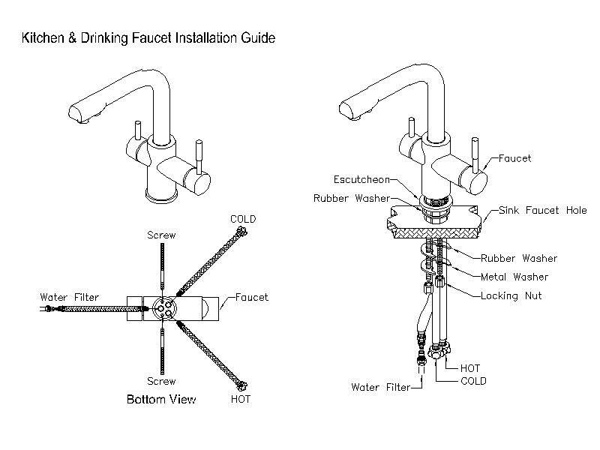 | 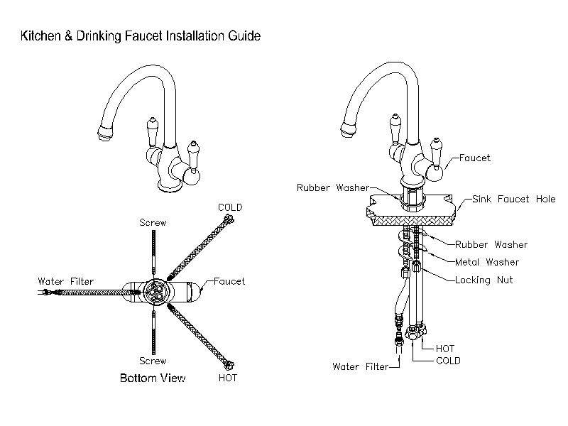

Step 3: Install faucet to sink top
- Refer to the diagram below for the correct location of all mounting washers and seals
- When assembly is complete, ensure that locking nuts are tightened securely to hold the faucet in place

Model KDF-02 Faucet | Model KDF-03 Faucet

Step 4: Fit Filter Bracket to Kitchen Unit
- Decide on the location of the filters – make sure that the screws for the bracket are at least 300mm above any shelf or the base of the unit so that you can change filters without having to remove the bracket first
- Drill the two holes and fit the bracket using the wall plugs and screws supplied

Step 5: Fit Saddle Tapping Valves to Hot and Cold Water Supply
- Locate the cold water mains supply pipe (this will be connected to the cold tap on your sink) and the hot water mains supply pipe (this will be connected to the hot tap on your sink). You need to attach saddle tapping valves to each of these pipes
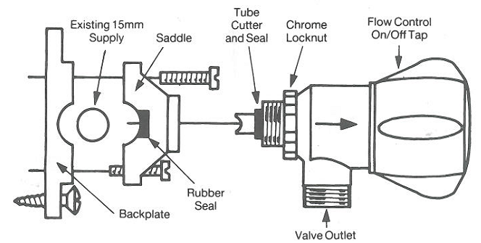
  - Position the valve outlet in the required direction
    - Screw the chrome locknut handtight against the valve shoulder
    - Screw valve into saddle until locknut contacts saddle
    - Decide which way round kit is to be fitted to pipe for positioning of valve outlet
  - Remove saddle from backing plate
  - Screw backing plate to wall – make sure that the pipe sits in the groove in the backing plate
  - Remove valve (complete with cutter and seal) from the saddle
  - Ensure the rubber seal is correctly located within the body of the saddle, then screw the saddle to the backing plate
  - Screw the valve into the saddle by hand until the locknut contacts the saddle – the water connection has now been made – Note: Do not overtighten the valve

Step 6: Install the Filter System
- Refer to the instructions supplied with the filter system to install the filter system correctly

Step 7: Complete all plumbing connections
- Refer to the diagram below for details of how the system should now be connected. Refer to the table at the front of this instruction sheet to identify the correct location of each component
- Please note the following
- Plastic tubing
    - You need 5 separate lengths of ¼” tubing to connect the components. Use a very sharp knife to cut the tube into the correct lengths
    - Cut tube ends straight and square – do not deform the tube (i.e. ensure that it is not compressed out of round)
    - Make sure that there are no nicks or cuts or scratches on the outside of the tube for the last 15mm of its length. This ensures that the tube will seal correctly on the fitting
    - Avoid sharp bends and kinks in the tubing

There are two different types of connection used to attach the components together. Follow the basic instructions below to ensure water-tight connections

Quick-Connect Fittings

To install a tube, push it into the collet until it seats firmly at the bottom of the fitting. Pull on the tube after installation to ensure it is fully seated into the connection

To remove a tube, push and hold the collet against the body of the fitting while pulling the tube out

Threaded connections

Use PTFE tape on all threaded connections

Use a C-spanner to tighten all threaded connections

Step 8: Complete Installation
- Open the tap on the sink
- Open the “Flow Control” valve on each of the saddle tapping valves (see drawing at “Step 5” above to identify the Flow Control valve)
- Switch on the mains water supply
- Leave the tap open for 30 seconds to bleed all air out of the pipes and flush the system and check for leaks

