 | Undersink Water Filter System  Installation Instructions – Glassfiller  037034-001

GENERAL INSTRUCTIONS:
- Do not use with water that is microbiologically unsafe or of unknown quality without adequate disinfection before or after the system
- Systems certified for cyst reduction (see “Performance Data” supplied with filter system) may be used on disinfected waters that may contain filterable cysts.

NOTICES:
- Install this filter on a cold water line only
- Water pressure – Minimum 1.5 bar ; Maximum 8 bar
- Protect unit from direct sunlight and freezing temperatures
- Clean unit with water safe products that will not taint drinking water – do not use bleach or spray cleaners
- This product is intended for indoor use only
- For extended periods of non-use, turn off the water supply and remove the filter cartridge. Place the filter cartridge in a sealed plastic bag and store in a refrigerator
- Before use, flush the filter media for 5 minutes
- Change the filter cartridge if changes in taste, colour or water flow occur
- Only use filter cartridges designed for use with this filtration system

KIT CONTENTS:

TOOLS NEEDED:
- Phillips screwdriver
- Sharp knife (e.g. Stanley knife)
- Electric drill & ½” (12.5mm or 13mm) drill bit

PRE INSTALLATION CHECKS:
- Ensure that there is sufficient space to install the product without hampering its operation. When fitting in a corner position make sure there is sufficient clearance for the use of the handles and the movement on the spout.
- Ensure that the outlet will protrude sufficiently into the sink(s) and will clear any obstructions.

INSTALLATION INSTRUCTIONS:
Step 1: Fit Tap to Sink
The tap may be installed either
- Through the work top adjacent to the sink (see Diagram 1)
- Through the stainless steel sink surround (see Diagram 2)
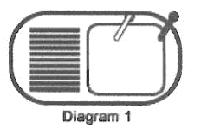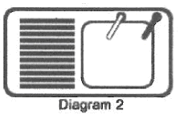
- Select your preferred location
  - Make sure that the spout of the tap is over the sink!
  - Ensure there is space under the sink to securely mount the faucet
  - Ensure there is a flat section at least 25mm in diameter to act as a sealing surface for the tap

A: Through the worktop  - Place masking tape over the proposed hole location  - Carefully score the centre position with a punch  - Drill 13mm hole  - NOTE: You must use a special cutter if drilling through granite, porcelain or other stone material  B: Through the sink surround  - Mark the centre position with a punch  - Drill 12.5mm hole  - Clean the drilled hole to ensure there are no sharp edges that could cut your fingers or the sealing washers  - Mount the tap to the sink – refer to diagram opposite to ensure all washers are installed correctly | 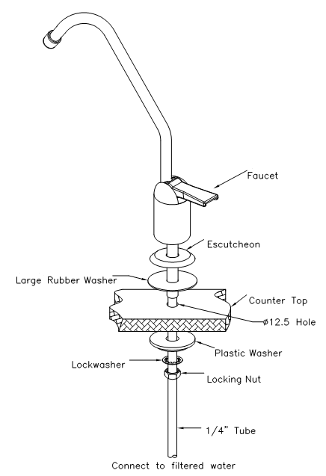

Step 2: Fit Filter Bracket to Kitchen Unit
- Decide on the location of the filters – make sure that the screws for the bracket are at least 300mm above any shelf or the base of the unit so that you can change filters without having to remove the bracket first
- Drill the two holes and fit the bracket using the wall plugs and screws supplied

Step 3: Fit Saddle Tapping Valve to Cold Water Supply
- Locate the cold water mains supply pipe (this will be connected to the cold tap on your sink).
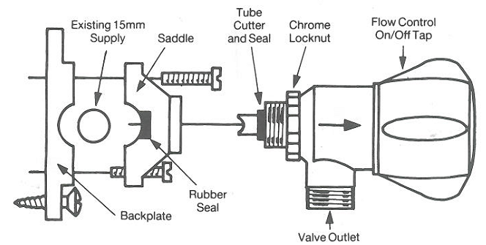
  - Position the valve outlet in the required direction
    - Screw the chrome locknut handtight against the valve shoulder
    - Screw valve into saddle until locknut contacts saddle
    - Decide which way round kit is to be fitted to pipe for positioning of valve outlet
  - Remove saddle from backing plate
  - Screw backing plate to wall – make sure that the pipe sits in the groove in the backing plate
  - Remove valve (complete with cutter and seal) from the saddle
  - Ensure the rubber seal is correctly located within the body of the saddle, then screw the saddle to the backing plate
  - Screw the valve into the saddle by hand until the locknut contacts the saddle – the water connection has now been made – Note: Do not overtighten the valve

Step 4: Install the Filter System
- Refer to the instructions supplied with the filter system to install the filter system correctly

Step 5: Connect All Tubing
- Refer to diagram below for the way in which all the tubes should be connected
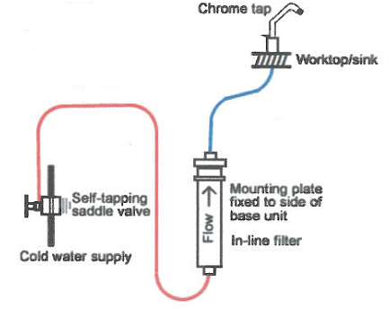
- Please note the following
- Plastic tubing
    - You need 2 separate lengths of ¼” tubing to connect the components. Use a very sharp knife to cut the tube into the correct lengths
    - Cut tube ends straight and square – do not deform the tube (i.e. ensure that it is not compressed out of round)
    - Make sure that there are no nicks or cuts or scratches on the outside of the tube for the last 15mm of its length. This ensures that the tube will seal correctly on the fitting
    - Avoid sharp bends and kinks in the tubing

There are two different types of connection used to attach the components together. Follow the basic instructions below to ensure water-tight connections

Quick-Connect Fittings

To install a tube, push it into the collet until it seats firmly at the bottom of the fitting. Pull on the tube after installation to ensure it is fully seated into the connection

To remove a tube, push and hold the collet against the body of the fitting while pulling the tube out

Threaded connections

Use PTFE tape on all threaded connections

Use a C-spanner to tighten all threaded connections

Step 6: Complete Installation
- Open the tap on the sink
- Turn the lever on the saddle valve clockwise as far as possible to pierce the pipe
- Turn the lever on the saddle valve anti-clockwise to open the valve
- Leave the tap open for 30 seconds to bleed all air out of the pipes and flush the system

